COFFEE SHOP SALES ANALYSIS DASHBOARD USING POWER BI – WEEK 6

Week 6 Report: Final Capstone Project Proposal

Submitted By: Jonnalagadda Venkata Naga Vishnusri

Internship: Virtual Power BI Data Visualization Internship

Organization: Henry Harvin Education in collaboration with Yuva Intern

Dataset: Coffee Shop Sales Dataset (Maven Analytics)

Tools Used: Microsoft Power BI

Submission Date: 04 September 2026

Project Title: Coffee Shop Sales Analysis Dashboard using Power BI – Week 6
Table of Contents:
- Executive Summary
- Introduction
- Project Objectives
- Project Scope
- Project Methodology
- Data Sources
- Data Model Architecture
- Visualization Plan
- Data Storytelling Approach
- Performance Optimization Strategies
- KPIs and Success Metrics
- Evaluation Framework
- Integration of Previous Week Concepts
- Expected Outcomes
- Conclusion

- Executive Summary:
The Coffee Shop Sales Analysis Dashboard using Power BI is a data analytics and visualization project designed to analyze coffee shop sales performance using transactional sales data. The project brings together strategic planning, data modeling, Power BI visualization, data storytelling, and performance optimization concepts learned throughout the internship.

The dashboard will provide meaningful insights into sales trends, product category performance, store location performance, transaction quantities, and top – performing products. Interactive visualizations and KPIs will help users understand business performance and identify areas that require attention.
The project will use the Coffee Shop Sales dataset containing transaction details such as transaction date, transaction time, transaction quantity, store location, product category, product type, product details, and unit price.

The final solution will focus on creating an interactive, user – friendly, performance – efficient Power BI dashboard that supports data-driven business decision – making.
- Introduction:

Coffee shops generate a large amount of transactional data through their daily sales activities. Analyzing this data can help businesses understand customer purchasing patterns, product performance, sales trends, and store-level performance.

This project uses Power BI to transform raw Coffee Shop Sales data into meaningful business insights. The dashboard will combine data preparation, modeling, visualization, storytelling, and optimization techniques to create a comprehensive analytical solution.
The project demonstrates how Power BI can be used to convert raw transactional data into an interactive business intelligence dashboard.

- Project Objectives:

The main objectives of the project are:

- To analyze overall coffee shop sales performance.
- To identify sales trends over time.
- To analyze sales performance by product category and product type.
- To compare performance across store locations.
- To identify the top – performing products.
- To create meaningful KPIs for business performance monitoring.
- To develop interactive Power BI visualizations.
- To apply data storytelling techniques.
- To implement an efficient data model.
- To improve report performance using Power BI optimization techniques.

- Project Scope:

The project will focus on analyzing Coffee Shop Sales transactional data using Power BI. The analysis will include:

- Sales performance analysis
- Product category analysis, Product type analysis, Store location analysis
- Time-based sales analysis
- Transaction quantity analysis, Top product analysis
- KPI monitoring
- Interactive filtering and exploration
- Dashboard performance optimization

The project will not focus on external factors such as customer demographics, employee performance, inventory management, or competitor analysis because these are not included in the selected dataset.
- Project Methodology:

The project will follow these major stages:

Data Collection → Data Preparation → Data Modeling → DAX/KPI Development → Visualization → Data Storytelling → Performance Optimization → Evaluation
Data Preparation

The dataset will be reviewed for data types, missing values, duplicates, and consistency.

- Data Modeling:
The data will be structured appropriately in Power BI to support efficient analysis.

- KPI Development:
Important business metrics such as total sales, total quantity, transaction count, and average transaction value will be considered.

- Visualization:
Suitable charts, KPI cards, slicers, and interactive elements will be used.

- Storytelling:
The dashboard will present insights in a logical sequence so users can understand the business performance easily.

- Optimization:
Power BI Performance Analyzer and optimization techniques will be considered to improve report responsiveness.

- Data Source:

The project will use the Coffee Shop Sales dataset. The dataset contains transactional information including:

- Transaction ID
- Transaction Date
- Transaction Time
- Transaction Quantity
- Store ID
- Store Location
- Product ID
- Unit Price
- Product Category
- Product Type
- Product Detail

Figure 1: Coffee Shop Sales Dataset used for the Project
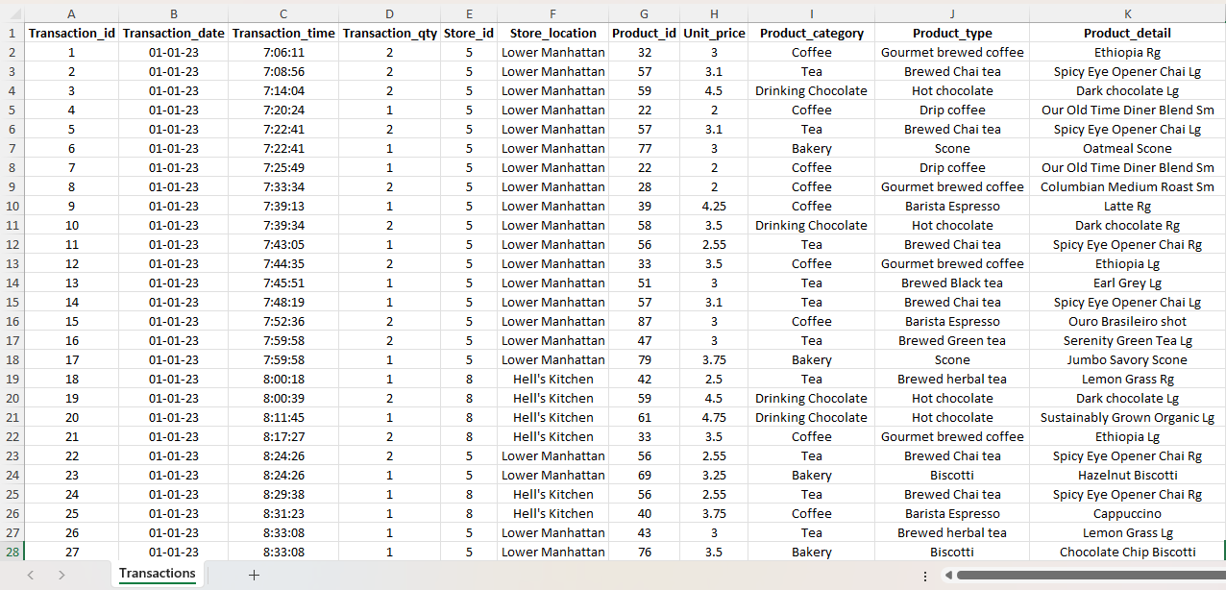

The dataset will serve as the primary source for Power BI analysis.

- Data Model Architecture:

The data model will be designed to support efficient reporting and analysis.

The transactional sales data will act as the primary source for analysis. Relevant fields will be organized logically to support calculations and visualizations.

The model will consider:

- Transaction information
- Date – related analysis
- Product – related analysis
- Store/location analysis
- Sales measures

Appropriate relationships and calculated measures will be used to improve analytical efficiency.

- Visualization Plan:

The proposed dashboard will include:

- KPI Cards:
- Total Sales
- Total Quantity Sold
- Total Transactions
- Average Transaction Value

- Sales Trend:

A line chart will show sales performance over time.

- Product Category Analysis:

A chart will compare sales across different product categories.

- Store Location Analysis:

A visual will compare sales performance across store locations.

- Top 10 Products:

A bar chart will display the top 10 products based on sales.

- Interactive Slicers:

Slicers will allow users to filter the report based on relevant dimensions such as date, store location, product category, and product type.

Figure 2: Coffee Shop Sales Analysis Dashboard in Power BI
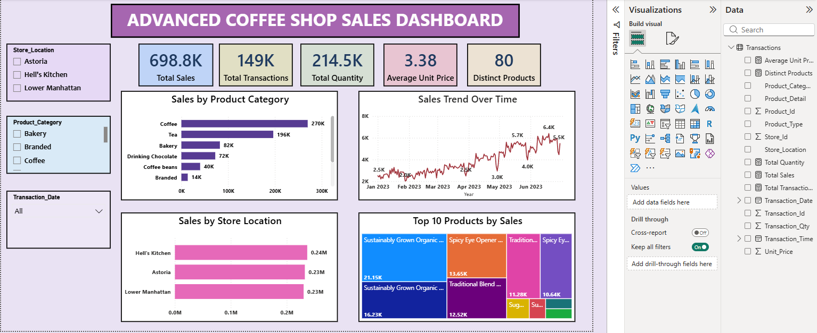

- Data Storytelling Approach:

The dashboard will follow a logical storytelling flow.

First, KPI cards will provide an overview of the overall business performance. The sales trend will then help users understand how performance changes over time.

Product and category analysis will identify which products contribute significantly to sales. Store location analysis will highlight differences between locations.

Finally, the Top 10 Products analysis will help identify the strongest – performing products.

This approach will allow users to move from overall performance → trends → categories → locations → products.

- Performance Optimization Strategies:

The project will consider the following optimization techniques:
- Reduce unnecessary columns and data.
- Use efficient data modeling.
- Avoid unnecessary complex calculations.
- Optimize DAX measures where required.
- Reduce excessive visuals on individual report pages.
- Use appropriate aggregations.
- Optimize slicers and filters.
- Use Power BI Performance Analyzer to identify potential performance issues.

The objective is to improve report responsiveness and reduce unnecessary processing.

Figure 3: Performance Analyzer Results Before Optimization

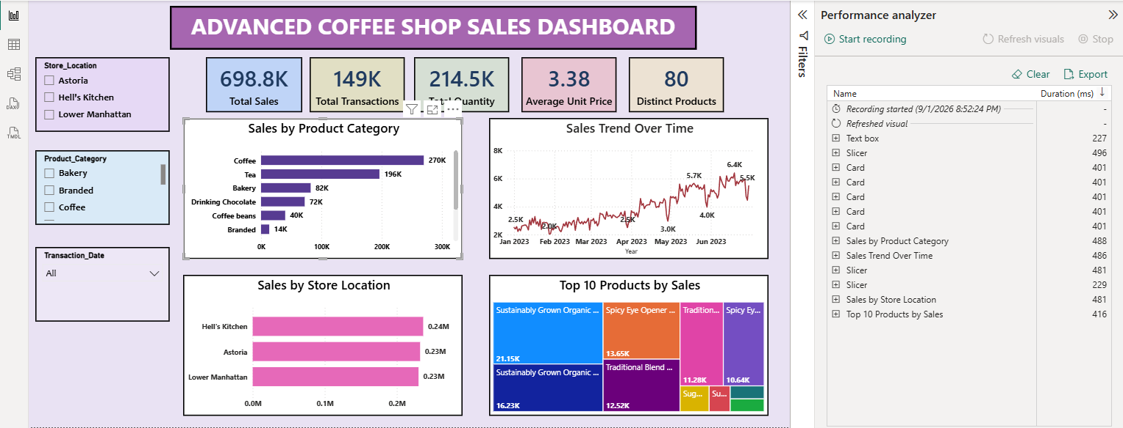

- KPIs and Success Metrics:

The project will evaluate performance using measurable KPIs such as:

- Total Sales
- Total Quantity Sold
- Total Transactions
- Average Transaction Value
- Sales by Product Category
- Sales by Store Location
- Top 10 Products
- Sales Trend Over Time

Success will be measured based on whether the dashboard provides clear, accurate, interactive, and useful insights.

- Evaluation Framework:

The final dashboard will be evaluated based on:

- Accuracy of analysis
- Clarity of visualizations
- Ease of navigation
- Quality of data storytelling
- Relevance of KPIs
- Data model efficiency
- Report responsiveness
- Overall user experience

Performance criteria such as Visual Loading Time, Query Duration, Report Responsiveness, and Overall Interaction Efficiency can also be considered when evaluating optimization.

- Integration of Previous Week Concepts:

This capstone project integrates the major concepts covered during the internship.

- Strategic Planning:

Defines project objectives, scope, KPIs, and expected outcomes.

- Data Modeling:

Organizes the sales data into an efficient structure for analysis.

- Advanced Visualization:

Uses KPI cards, charts, slicers, and interactive visuals to communicate insights.

- Data Storytelling:

Presents insights into a logical flow that makes business information easier to understand.

- Performance Optimization:

Use efficient modeling, query reduction, aggregation, and visual optimization techniques to improve report performance.

- Expected Outcomes:

The expected outcome of this project is an interactive Power BI dashboard that provides a clear overview of Coffee Shop sales performance.
The dashboard is expected to help users:

- Understand overall sales performance.
- Identify sales trends.
- Compare product categories.
- Evaluate store locations.
- Identify top-performing products.
- Monitor important KPIs.
- Explore data interactively.
- Make better data-driven decisions.

- Conclusion:

The Coffee Shop Sales Analysis Dashboard demonstrates the complete process of developing a Power BI business intelligence solution. The project integrates strategic planning, data modeling, visualization, storytelling, and performance optimization into a single comprehensive proposal.

By transforming transactional sales data into meaningful visual insights, the proposed dashboard can provide a practical approach to understanding coffee shop sales performance. The project also demonstrates the practical application of Power BI concepts learned during the internship and provides a foundation for developing efficient and user – friendly analytical dashboards.

